Independent Learning: German

w/c 16th March 2020

Create an account on Quizlet. If you have already an account, you can use this.
Use your school e-mail address and username.

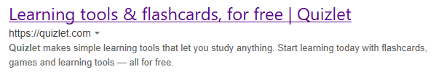

Below is the list of all Sydenham learning groups. Request to join the one that is right for you.
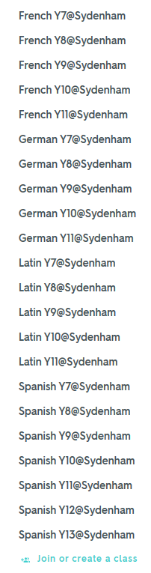

When you have send the request, you will have access to the learning material for your group. This is based on the Vocabulary&Grammar booklet that has been given to you at the beginning of the year.

German Y7@Sydenham
- Study vocabulary from 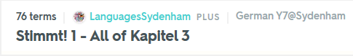and complete the Grammar pages in your booklet.
German Y8@Sydenham
- Study vocabulary from 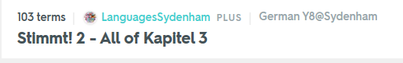and complete Grammar pages in your booklet.
GermanY9@Sydenham
- Study the sets 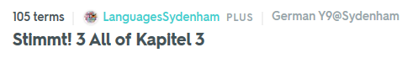and complete Grammar pages in your booklet.
German Y10@Sydenham
- Study the sets below. Look at speaking question examples. Can you improve your speaking questions?
