**Subject: Science**

Science involves the study of nature and requires experimentation, creativity and imagination in order to understand the universe at its deepest level.

There are three main branches of Science. Physics deals with the mechanics of how the universe works - what keeps planes 'up', us 'down' and the Earth spinning! Chemistry is the study of what things are made of and how they react. Everything from the explosions during Fireworks Night, to the materials we use every day. Biology involves studying living things and how they relate to each other in nature. You will also learn of how humans are impacting nature and the environment based on our activities.

**Key Stage Three**

All students will study Chemistry, Physics and Biology modules that are interleaved through the year. The units studied in Year 7 are: Cells - the building blocks of life Eating, drinking and breathing Elements, compounds and reactions Energy transfers and Sound Magnetism and electricity Mixing, dissolving and separating Forces and Effects 1 The units studied in Year 8 are: Explaining Physical Changes Explaining Chemical Changes Explaining Forces 2 Getting the Energy your Body Needs Looking at Plants and Ecosystems Waves and Energy

**Key Stage Four**

During Year 9, all students will be learning the Triple Science content for the following topics:

**In Biology**: Cells and Transport Control of Cell Growth Genetics

**In Chemistry**: States of Matter and Atomic Structure The Periodic Table Ionic and Covalent Bonding and Types of Substance Acids and Alkalis

**In Physics**: Motion and Forces Conservation of Energy Waves and the EM spectrum

In Year 10 and Year 11, students will either continue to study Combined Science (worth two GCSEs), or may be selected to study Triple Science - Chemistry, Physics and Biology.

Students who demonstrate that they have the aptitude and interest to achieve well in Triple Science will be selected to study this course. They will cover significantly more content in the same

**Key Stage Five**

At Key Stage 5, we offer Biology, Chemistry and Physics A Levels.

**In Biology** students study the following topics:

Year 12:

* Development of Practical Skills
* Foundations in Biology Exchange and Transport Biodiversity
* Evolution and Disease

Year 13:

* Communications
* Homeostasis and Energy Genetics
* Evolution and Ecosystems

**In Chemistry** students study the following topics:

Year 12

* Development of Practical Skills
* Foundations in Chemistry Periodic Table
* Energy Core Organic Chemistry

Year 13

* Physical Chemistry and Transition Element
* Organic Chemistry and Analysis

**In Physics** students study the following topics:

Year 12

* Development of Practical Skills
* Foundations of Physics Forces and Motion Electrons
* Waves and Photons

Year 13

* Newtonian World and Astrophysics
* Particles and Medical Physics

**Curriculum Breakdown Key Stage Three**

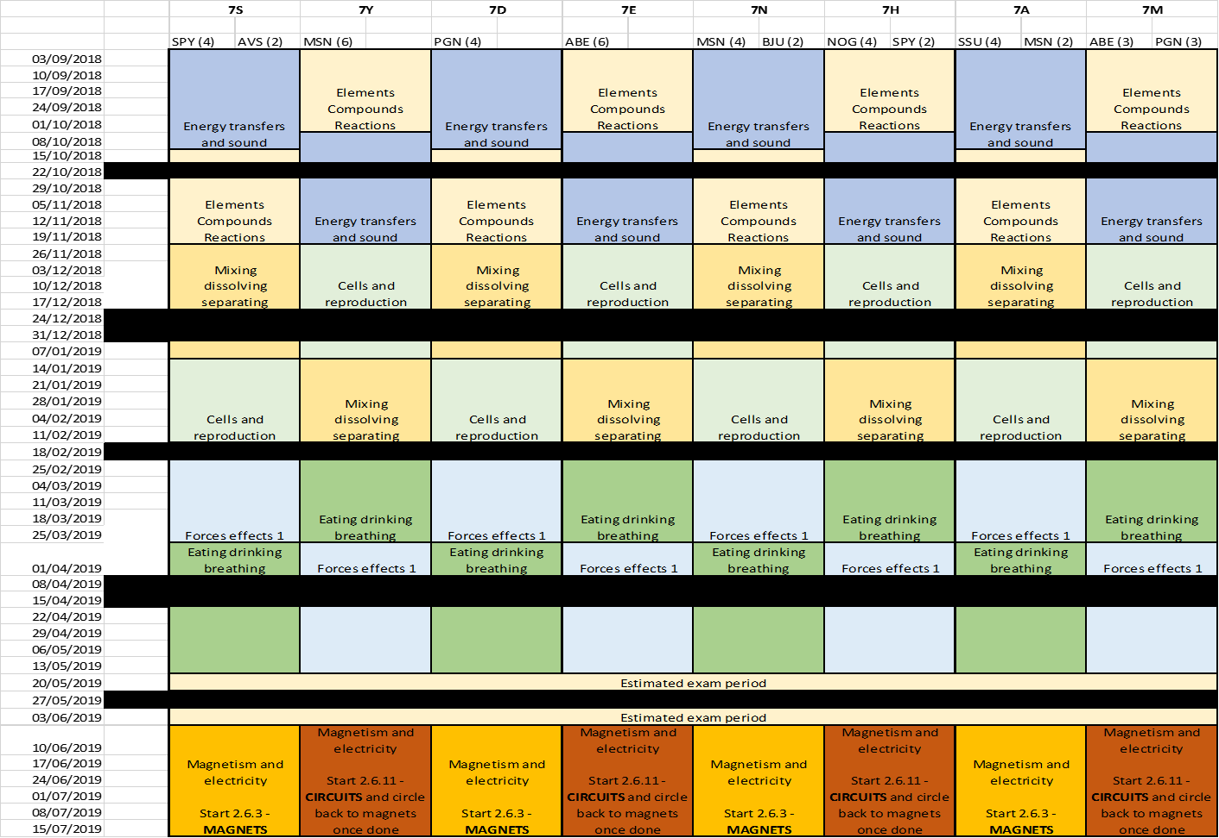

**Curriculum Breakdown Key Stage Four:**



**Curriculum Breakdown Key Stage Four: Year 10 Triple Science**



**Curriculum Breakdown Key Stage Four: Year 10 Combined Science**



**Curriculum Breakdown Key Stage Four: Year 11 Triple Science**



**Curriculum Breakdown Key Stage Four: Year 11 Combined Science**

