Year 9 English
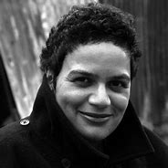
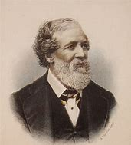
Stevie Smith
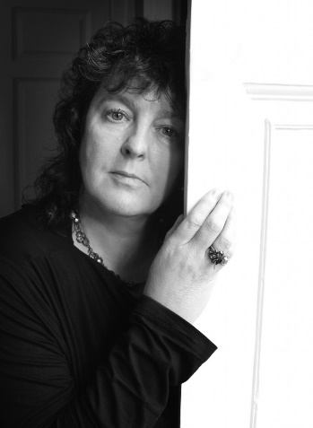
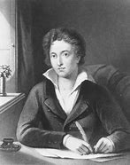
Jackie Kay
Robert Browning
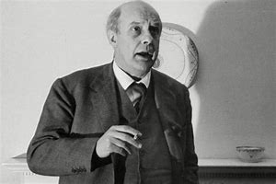
John Betjemen
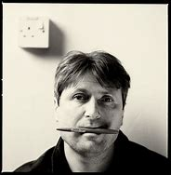
Carol Ann Duffy
Percy Shelley
U. A. Fanthorpe
Simon Armitage
Character and Voice Poetry
Contents
Timeline of English Literature…………………………………………………………………………………………………………….3
Knowledge organiser…………………………………………………………………………………………………………………………4
Key devices and terminology……………………………………………………………………………………………………………..5
Key vocabulary…………………………………………….…………………………………………………………………………………….6
The River God by Stevie Smith and model paragraph…………………………………………………………………………7
Casehistory: Alison (head injury) by U. A. Fanthorpe …………………………………………………………………………8
Model paragraphs – Case History and Medusa………………………………………………………………………………….9
Medusa by Carol Ann Duffy………………………………………………………………………………………………………………10
Give by Simon Armitage and model paragraph…………………………………………………………………………………11
Brendon Gallacher by Jackie Kay………………………………………………………………………………………………………12
Model paragraphs – Brendon Gallacher and On a Portrait……………………………………………………………….13
On A Portrait Of A Deaf Man by John Betjeman……………………………………………………………………………….14
Ozymandias by Percy Shelley and model paragraph…………………………………………………………………………15
My Last Duchess by Robert Browning………………………………………………………………………………………………16
My Last Duchess Model Paragraph and full marks essay example ……………………………………………………17
How to structure a comparative essay……………………………………………………………………………………………..19
Possible homework tasks………………………………………………………………………………………………………………….20

Timeline of English Literature
Look at where the poems we are studying fit in to the timeline.
How might you expect the themes and ideas discussed to change as time goes on?
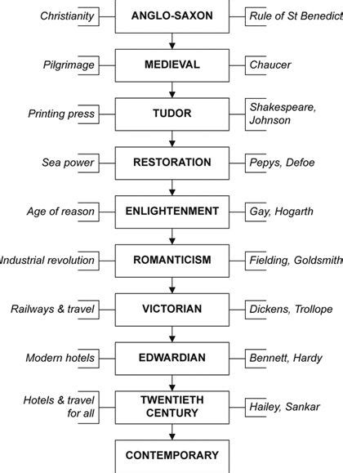
Keats, Shelley
Rousseau, Hume
Steinbeck
1842 ‘My Last Duchess’ by Robert Browning
1818 ‘Ozymandias’ by Percy Shelley
‘On a Portrait of a Deaf Man’ by John Betjemen
‘Casehistory: Allison [head injury]’ by U.A Fanthorpe
‘The River God’ by Stevie Smith
‘Medusa’ by Carol Ann Duffy
‘Brendon Gallacher’ by Jackie Kay
‘Give’ by Simon Armitage
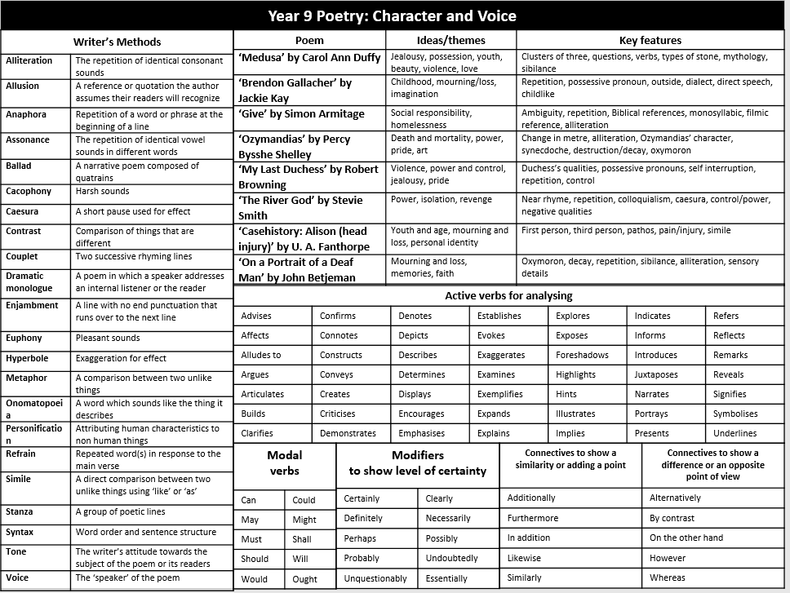
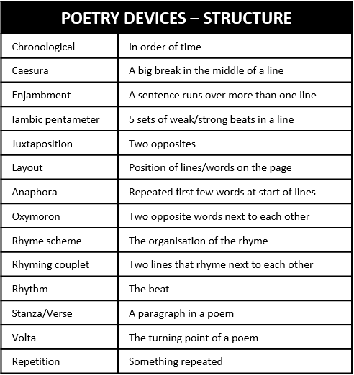
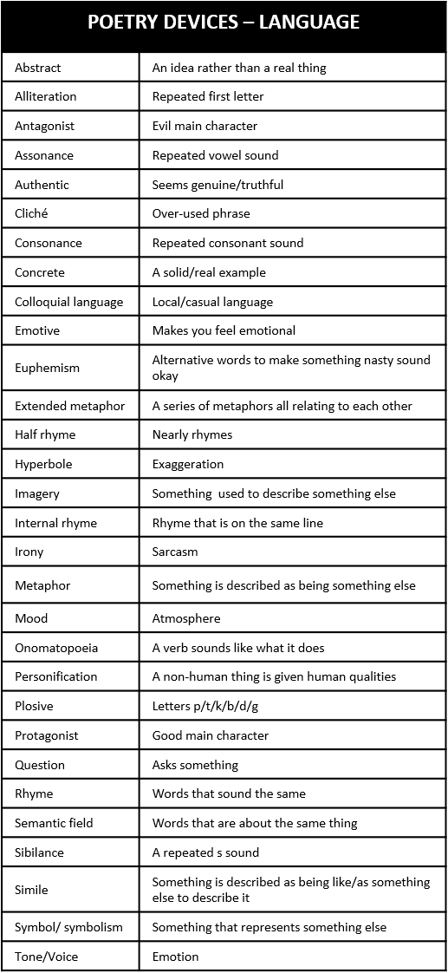

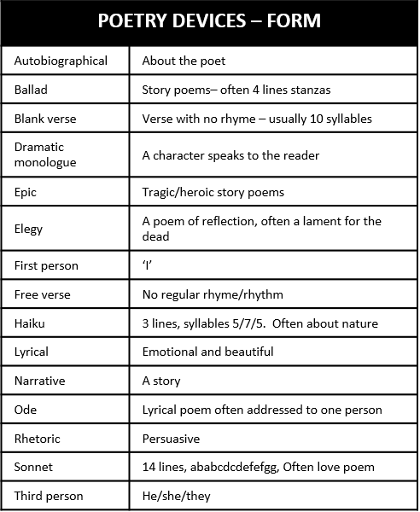

Vocabulary – Can you use these words to describe the characters and voices in the poems?
Word | Definition | Similar or related words | Which poem(s) does it relate to?
amiable | having a friendly and pleasant manner | friendly, warm-hearted, good-natured, likeable, agreeable
brazen | bold and without shame | shameless,bold
brusque | abrupt or short in speech or manner | short, sharp, blunt, caustic, abrasive
clandestine | kept secret or done secretly, perhaps because it is wrong | secret, covert, furtive, stealthy, surreptitious
despot | a ruler or other person who has absolute power | tyrant, dictator, autocrat, oppressor
eloquent | fluent or persuasive when speaking or writing | persuasive, expressive, articulate, expressive
fractious | difficult to control (when describing a group or organization) | wayward, unruly, uncontrollable, disobedient
jubilant | feeling or expressing great happiness or triumph | overjoyed, exultant, rejoicing, exuberant, thrilled
morose | sullen and bad-tempered | sulky, gloomy, surly, sour, glum, moody
zenith | the time at which something is most powerful or successful | highest point, high point, top, peak

The River God by Stevie Smith

I may be smelly and I may be old,
Rough in my pebbles, reedy in my pools,
But where my fish float by I bless their swimming
And I like the people to bathe in me, especially women.
But I can drown the fools
Who bathe too close to the weir, contrary to rules.
And they take a long time drowning
As I throw them up now and then in the spirit of clowning.
Hi yih, yippity-yap, merrily I flow,
O I may be an old foul river but I have plenty of go.
Once there was a lady who was too bold
She bathed in me by the tall black cliff where the water runs cold,
So I brought her down here
To be my beautiful dear.
Oh will she stay with me will she stay
This beautiful lady, or will she go away?
She lies in my beautiful deep river bed with many a weed
To hold her, and many a waving reed.
Oh who would guess what a beautiful white face lies there
Waiting for me to smooth and wash away the fear
She looks at me with. Hi yih, do not let her
Go. There is no one on earth who does not forget her
Now. They say I am a foolish old smelly river
But they do not know of my wide original bed
Where the lady waits, with her golden sleepy head.
If she wishes to go I will not forgive her.

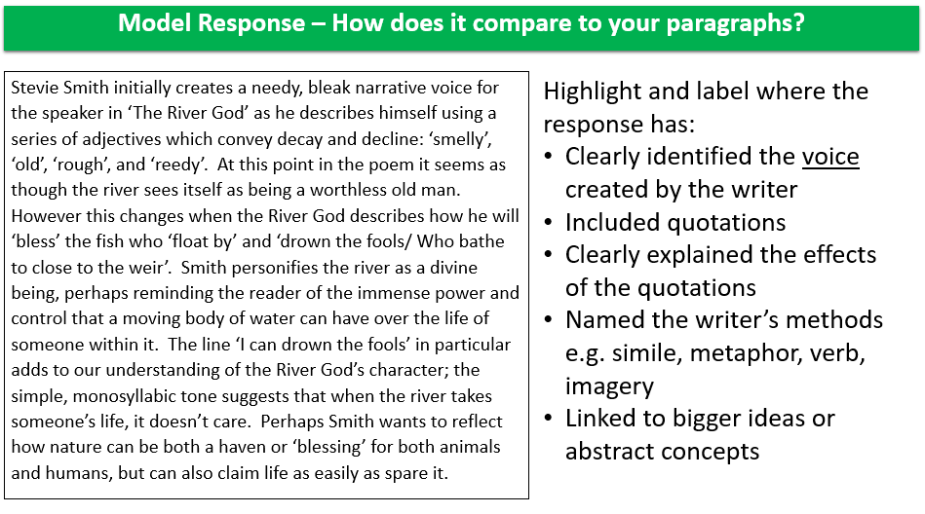

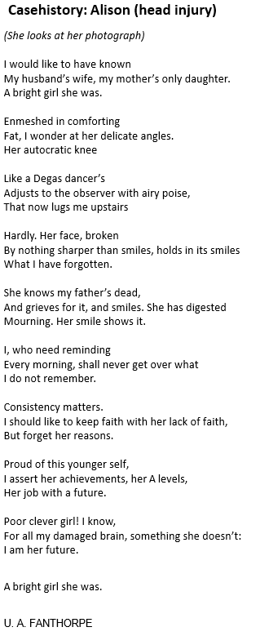
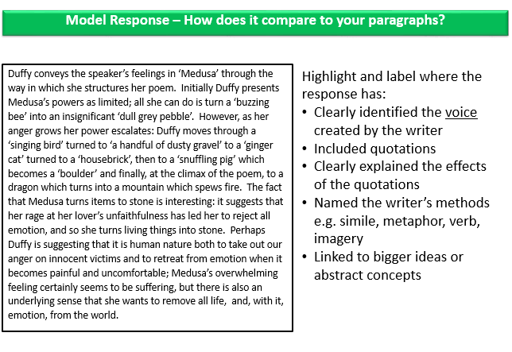
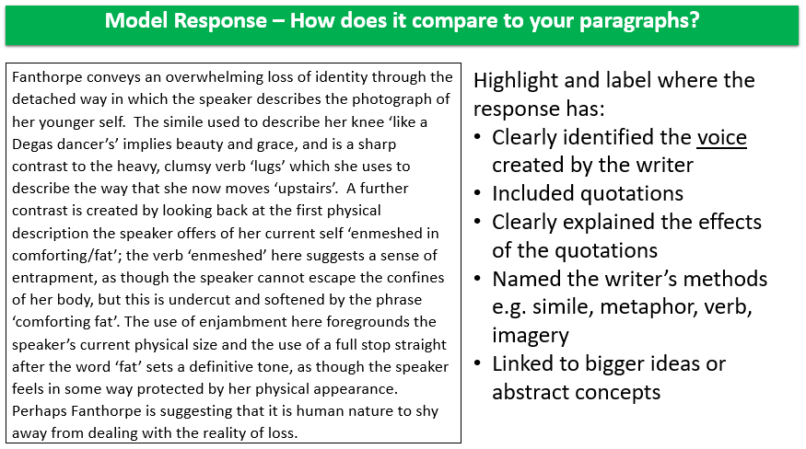

Medusa

A suspicion, a doubt, a jealousy
grew in my mind,
which turned the hairs on my head to filthy snakes
as though my thoughts
hissed and spat on my scalp.
My bride’s breath soured, stank
in the grey bags of my lungs.
I’m foul mouthed now, foul tongued,
yellow fanged.
There are bullet tears in my eyes.
Are you terrified?
Be terrified.
It’s you I love,
perfect man, Greek God, my own;
but I know you’ll go, betray me, stray
from home.
So better by for me if you were stone.
I glanced at a buzzing bee,
a dull grey pebble fell
to the ground.
I glanced at a singing bird,
a handful of dusty gravel
spattered down.

I looked at a ginger cat,
a housebrick
shattered a bowl of milk.
I looked at a snuffling pig,
a boulder rolled
in a heap of shit.
I stared in the mirror.
Love gone bad
showed me a Gorgon.
I stared at a dragon.
Fire spewed
from the mouth of a mountain.
And here you come
with a shield for a heart
and a sword for a tongue
and your girls, your girls.
Wasn’t I beautiful
Wasn’t I fragrant and young?
Look at me now.

Carol Ann Duffy

Give by Simon Armitage

Of all the public places, dear,
to make a scene, I’ve chosen here.

Of all the doorways in the world
to choose to sleep, I’ve chosen yours.
I’m on the street, under the stars.

For coppers I can dance or sing.
For silver – swallow swords, eat fire.
For gold – escape from locks and chains.

It’s not as if I’m holding out
for frankincense or myrrh, just change.

You give me tea. That’s big of you.
I’m on my knees. I beg of you.
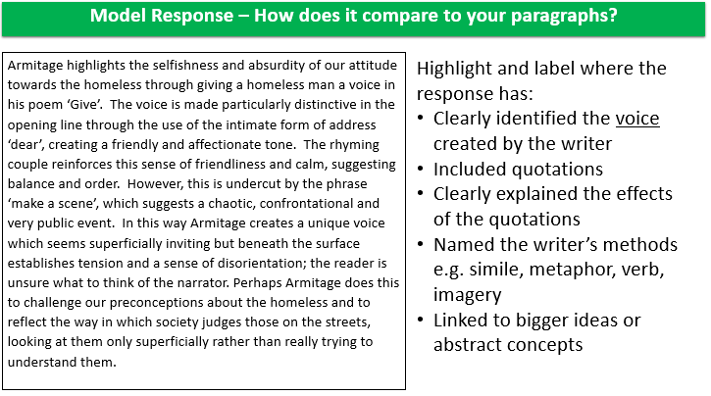

'Brendon Gallacher'

He was seven and I was six, my Brendon Gallacher.
He was Irish and I was Scottish, my Brendon Gallacher.
His father was in prison; he was a cat burglar.
My father was a communist party full-time worker.
He had six brothers and I had one, my Brendon Gallacher.

He would hold my hand and take me by the river
where we’d talk all about his family being poor.
He’d get his mum out of Glasgow when he got older.
A wee holiday some place nice. Some place far.
I’d tell my mum about my Brendon Gallacher

how his mum drank and his daddy was a cat burglar.
And she’d say, ‘Why not have him round to dinner?’
No, no, I’d say, he’s got big holes in his trousers.
I like meeting him by the burn in the open air.
Then one day after we’d been friends two years,

One day when it was pouring and I was indoors,
My mum says to me, ‘I was talking to Mrs Moir
who lives next door to your Brendon Gallacher
Didn’t you say his address was 24 Novar?
She says there are no Gallachers at 24 Novar

There never have been any Gallachers next door.’
And he died then, my Brendon Gallacher,
flat out on my bedroom floor, his spiky hair,
his impish grin, his funny, flapping ear.
Oh Brendon. Oh my Brendon Gallacher.

Jackie Kay

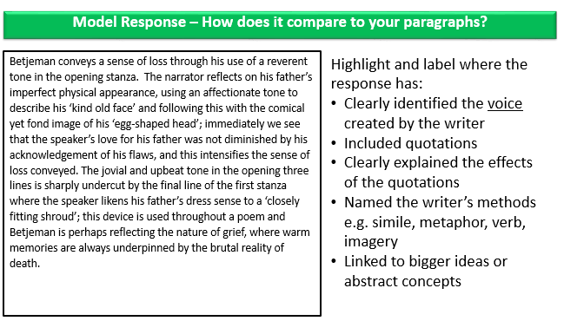
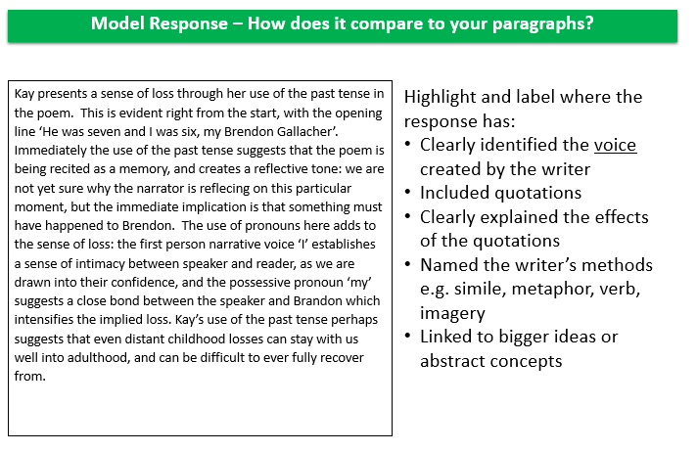
On a Portrait of a Deaf Man by John Betjeman
The kind old face, the egg-shaped head,
The tie, discreetly loud,
The loosely fitting shooting clothes,
A closely fitting shroud.

He liked old city dining rooms,
Potatoes in their skin,
But now his mouth is wide to let
The London clay come in.

He took me on long silent walks
In country lanes when young.
He knew the names of ev'ry bird
But not the song it sung.

And when he could not hear me speak
He smiled and looked so wise
That now I do not like to think
Of maggots in his eyes.

He liked the rain-washed Cornish air
And smell of ploughed-up soil,
He liked a landscape big and bare
And painted it in oil.

But least of all he liked that place
Which hangs on Highgate Hill
Of soaked Carrara-covered earth
For Londoners to fill.

He would have liked to say goodbye,
Shake hands with many friends,
In Highgate now his finger-bones
Stick through his finger-ends.

You, God, who treat him thus and thus,
Say "Save his soul and pray."
You ask me to believe You and
I only see decay.
Ozymandias by Percy Shelley
I met a traveller from an antique land
Who said: `Two vast and trunkless legs of stone
Stand in the desert. Near them, on the sand,
Half sunk, a shattered visage lies, whose frown,
And wrinkled lip, and sneer of cold command,
Tell that its sculptor well those passions read
Which yet survive, stamped on these lifeless things,
The hand that mocked them and the heart that fed.
And on the pedestal these words appear --
"My name is Ozymandias, king of kings:
Look on my works, ye Mighty, and despair!"
Nothing beside remains. Round the decay
Of that colossal wreck, boundless and bare
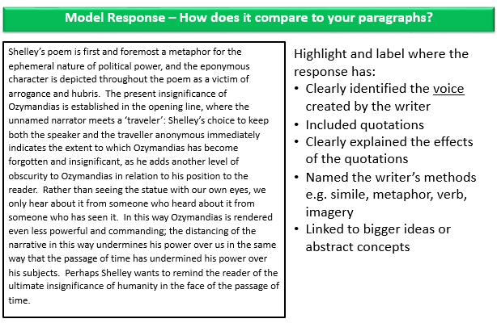
The lone and level sands stretch far away.

She rode with round the terrace – all and each
Would draw from her alike the approving speech,
Or blush, at least. She thanked men, – good! but thanked
Somehow – I know not how – as if she ranked
My gift of a nine-hundred-years-old name
With anybody’s gift. Who’d stoop to blame
This sort of trifling? Even had you skill
In speech – (which I have not) – to make your will
Quite clear to such an one, and say, ‘Just this
Or that in you disgusts me; here you miss,
Or there exceed the mark’ – and if she let
Herself be lessoned so, nor plainly set
Her wits to yours, forsooth, and made excuse,
– E’en then would be some stooping; and I choose
Never to stoop. Oh sir, she smiled, no doubt,
Whene’er I passed her; but who passed without
Much the same smile? This grew; I gave commands;
Then all smiles stopped together. There she stands
As if alive. Will’t please you rise? We’ll meet
The company below, then. I repeat,
The Count your master’s known munificence
Is ample warrant that no just pretence
Of mine for dowry will be disallowed;
Though his fair daughter’s self, as I avowed
At starting, is my object. Nay, we’ll go
Together down, sir. Notice Neptune, though,
Taming a sea-horse, thought a rarity,
Which Claus of Innsbruck cast in bronze for me!
ROBERT BROWNING

My Last Duchess
Ferrara
That’s my last Duchess painted on the wall,
Looking as if she were alive. I call
That piece a wonder, now: Frà Pandolf’s hands
Worked busily a day, and there she stands.
Will’t please you sit and look at her? I said
‘Frà Pandolf’ by design, for never read
Strangers like you that pictured countenance,
The depth and passion of its earnest glance,
But to myself they turned (since none puts by
The curtain I have drawn for you, but I)
And seemed as they would ask me, if they durst,
How such a glance came there; so, not the first
Are you to turn and ask thus. Sir, ’twas not
Her husband’s presence only, called that spot
Of joy into the Duchess’ cheek: perhaps
Frà Pandolf chanced to say ‘Her mantle laps
Over my lady’s wrist too much,’ or ‘Paint
Must never hope to reproduce the faint
Half-flush that dies along her throat’: such stuff
Was courtesy, she thought, and cause enough
For calling up that spot of joy. She had
A heart – how shall I say? – too soon made glad,
Too easily impressed; she liked whate’er
She looked on, and her looks went everywhere.
Sir, ’twas all one! My favour at her breast,
The dropping of the daylight in the West,
The bough of cherries some officious fool
Broke in the orchard for her, the white mule

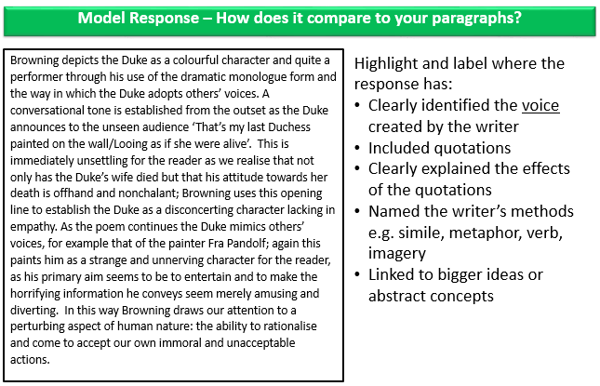
Full marks response: Compare the ways the poets present ideas about power in Ozymandias and one other poem from Character and Voice.

Both ‘Ozymandias’ and ‘The River God’ are poems that create a character for whom power is a central concern. In ‘Ozymandias’, Shelley indirectly creates a voice of an Egyptian king, Ramesses II, but does this through the distancing narrative frame of a traveller 'from an antique land.' This sense of distance diminishes and undermines the sense of power given to the subject, Ozymandias. By contrast, in ‘The River God’ Stevie Smith creates the persona of a river who has great and enduring physical power, but feels unappreciated and neglected.
The nature of power in ‘Ozymandias’ is expressed in terms of tyrannical, cruel behaviour. The remains of a 'vast' statue are 'stamp'd' with a 'frown' and a 'sneer of cold command'. It is evident that Ozymandias ruled as a tyrant, without regard for the people. The phrase 'the hand that mock'd them and the heart that fed' suggests that he gained his strength and power from, and at the expense of, his people. However, the end of the poem undermines this power. The irony of the inscription on the pedestal is highlighted by the simple phrase 'Nothing beside remains', suggesting that nothing lasts forever - even great civilisations will eventually crumble and 'decay.' This word is a key word in the poem. Shelley is suggesting that decay and decline is inevitable. Perhaps this can also be read as a warning for our own society, for western civilisation, or for humankind in general: nothing lasts forever.

By contrast, ‘The River God’ begins in quite defensive fashion, with the assertion that 'I may be smelly and I may be old'; the voice created immediately gives the impression that it is defending itself and feels insecure and unappreciated. We get a sense of the River God's sense of fun (‘Hi yih, yippity-yap, merrily I flow’) and its appreciation of beauty - in fact the word 'beautiful' appears four times. However, the overwhelming sense of insecurity and bitterness carries a hint of threat. There is a threat to the swimmers, who 'take a long time drowning... In the spirit of clowning'. The use of rhyme here implies a sense of sadistic and light-hearted enjoyment in inflicting death on the powerless humans. However, mixed in with this sense of power is a feeling of powerlessness and insecurity in the final line about his 'beautiful dear': 'If she wishes to go I will not forgive her.' Both of these poems seem to create voices of timeless power, but below the surface there is a suggestion of vulnerability.

‘Ozymandias’ is written in the form of a sonnet, and with this particular form comes a regular rhyme scheme and rhythm, creating a sense of order. This neatness and orderliness underlines the simple, undeniable truth at the heart of the poem: nothing lasts forever. The simplicity and conciseness of the poem’s form makes this simple message all the more powerful. In contrast, ‘The River God’ creates moments of orderliness with its heavy use of rhyme, but the slight inconsistencies in the rhyme scheme suggest the contrasting feelings of power and powerlessness the speaker feels. The defensive opening lines do not rhyme, and many of the final lines end with the repetitive 'her' suggesting his paranoia and obsession. In contrast, moments of humour sound stronger with perfect feminine rhymes (‘drowning’/ ‘clowning’) or strong masculine ones (‘flow’/ ‘go’). The long, flowing single stanza and the use of enjambment suggest a continuous flow – like a river. This perhaps suggests the relentless power of the river despite moments of weakness.

Finally, both poets’ language choices clearly establish their underlying messages about power and powerlessness. Shelley’s language choices in ‘Ozymandias’ create an overall sense of destruction, lifelessness and decay. The poem is set in a 'desert', which is a symbol of infertility and death, and the remains of the statue are described as 'lifeless'. By the end of the poem, this is further emphasised by using the alliteration of 'boundless and bare' to emphasise this harsh reality, and then further by the use of the word 'wreck.' Even the word 'remains', here used as a verb, has a more destructive and powerful meaning when considered as a noun: what is left of something that has been destroyed.

By contrast, ‘The River God’s language is simple and direct, creating a colloquial and very human voice for the river. The first line is largely monosyllabic, and the general pattern of simple language continues throughout. Colloquial idioms further emphasise this sense of humanity, with phrases like 'plenty of go' helping to create a persona we can relate to. This sense of an unappreciated character with literal and metaphorical hidden depths is developed as the poem goes on. His obsession is revealed through the repetition of 'beautiful' and 'her', but the dark reality of the situation to the reader is emphasised through the descriptions of her 'white face' and her 'golden sleepy head'. These seem to suggest beauty, but also strongly suggest death - and the power of the river to inflict it. There is an awkward contrast between the River God’s casual take on the situation and our own. Finally, the phrase 'wide original bed' provides a sense of power that is missing from Ozymandias - a sense of permanence. The interesting use of the word 'original' suggests that the river has always been there and always will. In this poem, Stevie Smith seems to be demonstrating the dangerous power of nature and warning us of the deadly consequences of showing no respect for that power. In contrast, the end of Shelley’s poem provides a scene of peace and emptiness after the rule of Ozymandias as the 'lone and level sands stretch far away.' The soft, alliterative sounds of this final line show that there is no longer any echo of the tyrannical power that once existed there.

Highlight and label where the response has:
- Clearly identified the voice created by the writer
- Included quotations
- Clearly explained the effects of the quotations
- Named the writer’s methods e.g. simile, metaphor, verb, imagery
- Linked to bigger ideas or abstract concepts
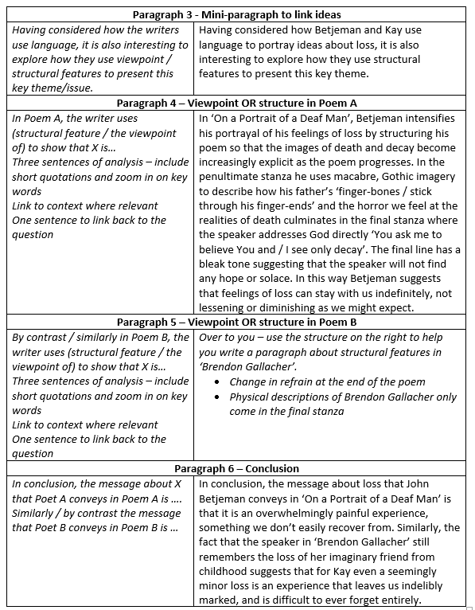
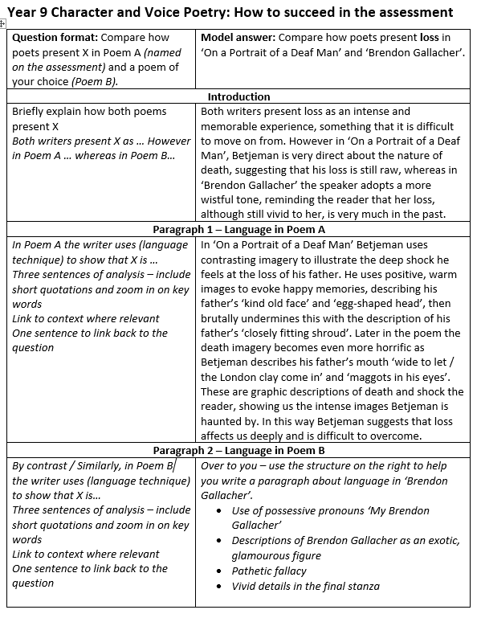

Homework tasks – your teacher may set tasks from this bank OR may set tasks of their own.
- Use Look – Cover – Write – Check to learn all the Language devices for a quick quiz next lesson.
- Use Look – Cover – Write – Check to learn all the Structure and Form devices for a quick quiz next lesson.
- Use Look – Cover – Write – Check to learn the active verbs for analysing for a quiz quiz next lesson.
- Create flashcards with key quotations for each poem and test yourself for 10 minutes every day to prepare for your assessment.
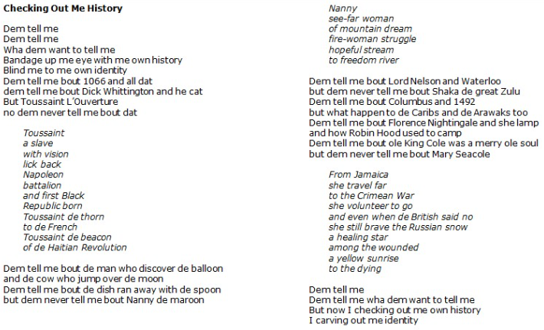
- Read John Agard’s poem ‘Checking Out Me History. In this poem Agard explore how we are educated and how it can be biased; he reflects on all the significant figures from black culture and history that he was not taught about in school.
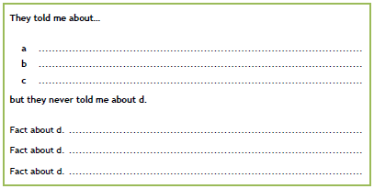
Then write your own poem in the same style using the structure below. You could write about anything where information has been kept from you or where certain aspects of history have been emphasised over others. You could think about your parents, the government, society, school…For example, in the first list you could mention nursery rhymes, fairytales or childhood ‘facts’ told to children. The second list could be based on distorted or suppressed facts or realities.
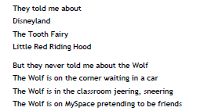
Example:

